**BANK MANAGEMENT SYSTEM**

**PROJECT REPORT**

**[Submitted in partial fulfillment of the requirements for the award of the Degree Master of Computer Application (MCA) Program GEU**

**GRAPHIC ERA (DEEMED TO BE) UNIVERSITY**

**(DEHRADUN)**



**Submitted by**

**NILASISH BANERJEE**

**MCA: 2th Sem. / 1st Year**

**Roll No.: 1102263 Enroll. No.: GE-21112263**

**(Batch: 2021-2023)**

**Department of Computer Applications**

**GRAPHIC ERA (DEEMED TO BE) UNIVERSITY (DEHRADUN)**

**CERTIFICATE**

This is to certify that the project report entitled **“BANK ACCOUNT MANAGEMENT”** is submitted by **Mr. NILASISH BANERJEE** in partial fulfillment of the requirements for the award of the degree of **Master of Computer Application (MCA)** as a record of bonafide work done by him/her under our supervision and guidance.

Signature

Ms. Vandana Rawat **(Project Guide)**

**STUDENT DECLARATION**

This is to certify that the project report entitled BANK ACCOUNT MANAGEMENT SYSTEM submitted to Graphic Era University, Dehradun in partial fulfilment of the requirement for the award of the degree of MASTERS OF COMPUTER APPLICATIONS (BCA), is an authentic and original work carried out by Mr. Nilasish Banerjee with enrolment number GE-21112263 under my supervision and guidance. The matter embodied in this project is genuine work done by the student and has not been submitted whether to his University or to any other University/Institute for the fulfilment of the requirements of any course of study.

Signature of the Student:

Date: 10-05-2022

Enrolment No.: GE-19211709

Signature of the Guide Date: 10-05-2022

**ACKNOWLEDGEMENT**

This Project report was completed as a result . I wish to express our sincere gratitude to God for his protection, providence, guidance and above all, for sustaining us. I greatly indebted to our good supervisor **Ms. Vandana Rawat** for her useful and necessary observation, suggestions, contribution and corrections. I would not have been able to achieve anything in this research without your supervision. May God enrich you greatly in every area of life.

Finally, I wish to express my appreciation to our parents for their love and support.

**NILASISH BANERJEE**

**Student’s Name**

**Table of Content**

**1. Candidate's Declaration**

**2. Internal Guide Certificate 3. Acknowledgement**

**4. ABSTRACT**

**Chapter 1**

**a. Introduction b. AIM of this project**

**c. Main purpose**

**d. Administrative Modules**

**e. Benefits of Online Banking**

**Chapter 2**

**a. Feasibility Study**

**b. System Requirements**

**c. Software Development Lifecycle**

**Chapter 3**

**a. Introduction to Front End b. Introduction to Back End**

**c. Data Flow Diagrams**

**d. Data Structuresand Database Specifications**

**Chapter 4**

**Design**

**Chapter 5**

**Coding**

**Chapter6**

**a. Conclusion b. Future Outlook**

**Reference/Bibliography**

**Abstract**

The Bank Account Management System is an application for maintaining a person's account in a bank. In this project I tried to show the working of a banking account system and cover the basic functionality of a Bank Account Management System. To develop a project for solving financial applications of a customer in banking environment in order to nurture the needs of an end banking user by providing various ways to perform banking tasks. Also, to enable the user’s work space to have additional functionalities which are not provided under a conventional banking project.

The Bank Account Management System undertaken as a project is based on relevant technologies. The main aim of this project is to develop software for Bank Account Management System. This project has been developed to carry out the processes easily and quickly, which is not possible with the manuals systems, which are overcome by this software. This project is developed using Java language. Creating and managing requirements is a challenge of IT, systems and product development projects or indeed for any activity where you have to manage a contractual relationship. Organization need to effectively define and manage requirements to ensure they are meeting needs of the customer, while proving compliance and staying on the schedule and within budget.

The impact of a poorly expressed requirement can bring a business out of compliance or even cause injury or death. Requirements definition and management is an activity that can deliver a high, fast return on investment. The project analyzes the system requirements and then comes up with the requirements specifications. It studies other related systems and then come up with system specifications. The system is then designed in accordance with specifications to satisfy the requirements. The system design is then implemented with Java. The system is designed as an interactive and content management system. The content management system deals with data entry, validation confirm and updating whiles the interactive system deals with system interaction with the administration and users. Thus, above features of this project will save transaction time and therefore increase the efficiency of the system

**AIM of this project**

The main aim of designing and developing this Internet banking System Java primarily based Engineering project is to provide secure and efficient net banking facilities to the banking customers over the internet. Apache Server Pages, MYSQL database used to develop this bank application where all banking customers can login through the secured web page by their account login id and password. Users will have all options and features in that application like get money from western union, money transfer to others, and send cash or money to inter banking as well as other banking customers by simply adding them as payees.

**Main Purpose**

The Traditional way of maintaining details of a user in a bank was to enter the details and record them. Every time the user needs to perform some transactions he has to go to bank and perform the necessary actions, which may not be so feasible all the time. It may be a hard-hitting task for the users and the bankers too. The project gives real life understanding of Online Banking System and activities performed by various roles in the supply chain. Here, we provide automation for banking system through Internet. Online Banking System project captures activities performed by different roles in real life banking which provides enhanced techniques for maintaining the required information up-to-date, which results in efficiency. The project gives real life understanding of Online Banking System and activities performed by various roles in the supply chain

**Main Goal**

**1. Motto-** Our motto is to develop a software program for managing the entire bank process related to Administration accounts customer accounts and to keep each every track about their property and their various transaction processes efficiently.

Hereby, our main objective is the customer’s satisfaction considering today’s faster in the world.

**2. Customer Satisfaction**: Client can do his operations comfortably without any risk or losing of his privacy. Our software will perform and fulfill all the tasks that any customer would desire.

**3. Saving Customer Time**: Client doesn't need to go to the bank to do small operation.

**4. Protecting the Customer:** It helps the customer to be satisfied and comfortable in his choices, this protection contains customer’s account, money and his privacy.

**5. Transferring Money:** Help client transferring money to/or another bank or country.

**Methods**

• We need to be able to generate an account number

• Account types: Savings or Current Account

• Maintain/update Balance

• Open/Close Account

• Withdraw/Deposit

**Administrative Modules**

Here in my project there are two types of modules. This module is the main module which performs all the main operations in the system. The major operations in the system are:

**Admin Module**

Admin can access this project there is an authorization process. If you login as an Admin then you will be redirected to the Admin Home Page and if you are a simple user you will be redirected to your Account Home Page. This performs the following functions: Create

Individual Accounts, manage existing accounts, View all transactions, Balance enquiry,

Delete/close account etc.

1- Admin login

2- Add/delete/update account

3- Withdrawal/deposit/statements transaction

4- Account Information

5- User details list

6- Active/Inactive account

7- View transaction histories

**User Module**

A simple user can access their account and can deposit/withdraw money from their account.

User can also transfer money from their account to any other bank account. User can see their transaction report and balance enquiry too.

1- User login, use PIN system

2- Creating/open new account registration

3- Funds transfer (local/international/domestic)

4- View statements transaction

5- User account details

6- Change Password and Pin

**Banks terms**:

1. All requests received from customers are logged for backend fulfillment and are effective from the time they are recorded at the branch.

2. Rules and regulations applicable to normal banking transactions in India will be applicable mutatis mutandis for the transactions executed through this site.

3. The BAMS Bank service cannot be claimed as a right. The bank may also convert this into a discretionary service anytime.

4. Dispute between the customer and the Bank in this service is subject to the jurisdiction of the courts in the Republic of India and governed by the laws prevailing in India.

5. The Bank reserves the right to modify the services offered or the Terms of service of BAMS Bank. The changes will be notified to the customers through a notification on the Site.

**Customer’s obligations**

1. The customer has an obligation to maintain secrecy in regard to Username & Password registered with the Bank. The bank presupposes that login using valid Username and Password is a valid session initiated by none other than the customer.

2. Transaction executed through a valid session will be construed by RR to have emanated from the registered customer and will be binding on him/her.

3. The customer will not attempt or permit others to attempt accessing the BAMS Bank through any unlawful means.

**Benefits of online banking**

Many of us lead busy lives. Some of us are up before the crack of dawn, getting ourselves prepared so we can in turn get our families ready for the day. We rush to work, rush to get the kids to school, and at the end of the day we rush home only to brace ourselves for the next day. After a hectic day, the last thing you want to do is spend time waiting in line at the bank, or even the post office. That's where Online Banking comes in. Many of the benefits of doing our banking online are obvious:

1- You don't have to wait in line.

2- You don't have to plan your day around the bank's hours.

3- You can look at your balance whenever you want, not just when you get a statement.

There are some hidden benefits too. As a young bank customer, you're just learning how to manage your money and observe your spending patterns.

Online banking allows you to watch your money on a daily basis if you want to. By keeping close tabs on your funds, you'll always be aware of what's happening in your bank account.

For those experienced spenders, this option is far more appealing than the sudden discovery that you're broke!

It's also helpful to watch how much interest you're gathering on investments and savings or what service charges you have incurred.

**Most available benefits**

1. Online banking with key bank is fast, secure, convenient and free.

2. Quick, simple, authenticated access to accounts via the web application.

3. Simply scalable to grow with changing system requirement.

4. Global enterprise wide access to information.

5. Improved data security, restricting unauthorized access.

6. Minimize Storage Space.

**DESIGN & CODING**

**Login Page**

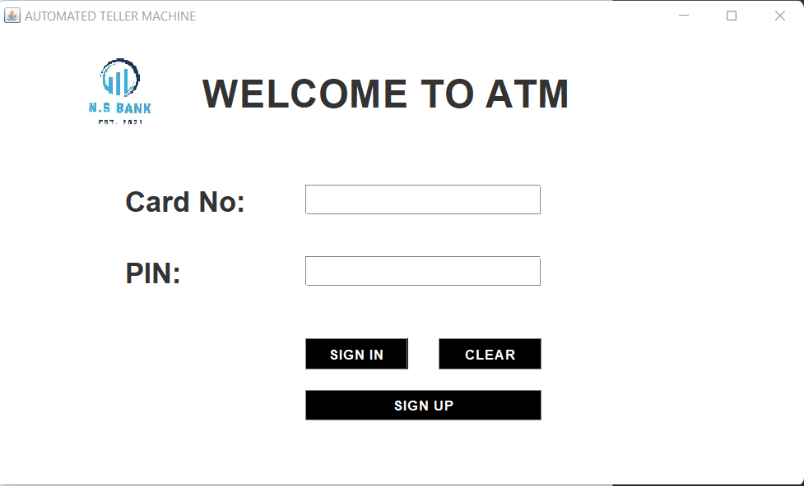

Code For login:

package ASimulatorSystem;

import java.awt.*;

import java.awt.event.*;

import javax.swing.*;

import java.sql.*;

public class Login extends JFrame implements ActionListener{

JLabel l1,l2,l3;

JTextField tf1;

JPasswordField pf2;

JButton b1,b2,b3;

Login(){

setTitle("AUTOMATED TELLER MACHINE");

ImageIcon i1 = new ImageIcon(ClassLoader.getSystemResource("ASimulatorSystem/icons/lg.jpg"));

Image i2 = i1.getImage().getScaledInstance(150, 150, Image.SCALE_DEFAULT);

ImageIcon i3 = new ImageIcon(i2);

JLabel l11 = new JLabel(i3);

l11.setBounds(70, 10, 100, 100);

add(l11);

l1 = new JLabel("WELCOME TO ATM");

l1.setFont(new Font("Osward", Font.BOLD, 38));

l1.setBounds(200,40,450,40);

add(l1);

l2 = new JLabel("Card No:");

l2.setFont(new Font("Raleway", Font.BOLD, 28));

l2.setBounds(125,150,375,30);

add(l2);

tf1 = new JTextField(15);

tf1.setBounds(300,150,230,30);

tf1.setFont(new Font("Arial", Font.BOLD, 14));

add(tf1);

l3 = new JLabel("PIN:");

l3.setFont(new Font("Raleway", Font.BOLD, 28));

l3.setBounds(125,220,375,30);

add(l3);

pf2 = new JPasswordField(15);

pf2.setFont(new Font("Arial", Font.BOLD, 14));

pf2.setBounds(300,220,230,30);

add(pf2);

b1 = new JButton("SIGN IN");

b1.setBackground(Color.BLACK);

b1.setForeground(Color.WHITE);

b2 = new JButton("CLEAR");

b2.setBackground(Color.BLACK);

b2.setForeground(Color.WHITE);

b3 = new JButton("SIGN UP");

b3.setBackground(Color.BLACK);

b3.setForeground(Color.WHITE);

setLayout(null);

b1.setFont(new Font("Arial", Font.BOLD, 14));

b1.setBounds(300,300,100,30);

add(b1);

b2.setFont(new Font("Arial", Font.BOLD, 14));

b2.setBounds(430,300,100,30);

add(b2);

b3.setFont(new Font("Arial", Font.BOLD, 14));

b3.setBounds(300,350,230,30);

add(b3);

b1.addActionListener(this);

b2.addActionListener(this);

b3.addActionListener(this);

getContentPane().setBackground(Color.WHITE);

setSize(800,480);

setLocation(550,200);

setVisible(true);

}

public void actionPerformed(ActionEvent ae){

try{

if(ae.getSource()==b1){

Conn c1 = new Conn();

String cardnumber = tf1.getText();

String pin = pf2.getText();

String q = "select * from login where cardnumber = '"+cardnumber+"' and pin = '"+pin+"'";

ResultSet rs = c1.s.executeQuery(q);

if(rs.next()){

setVisible(false);

new Transactions(pin).setVisible(true);

}else{

JOptionPane.showMessageDialog(null, "Incorrect Card Number or PIN");

}

}else if(ae.getSource()==b2){

tf1.setText("");

pf2.setText("");

}else if(ae.getSource()==b3){

setVisible(false);

new Signup().setVisible(true);

}

}catch(Exception e){

e.printStackTrace();

}

}

public static void main(String[] args){

new Login().setVisible(true);

}

}

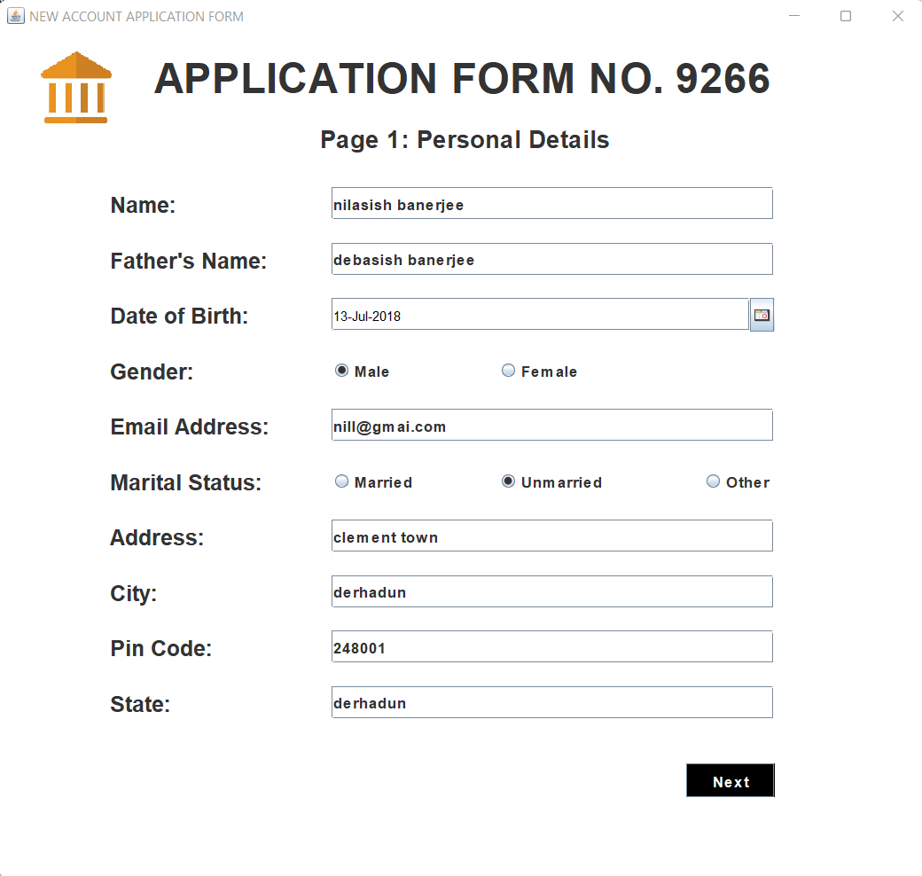

**For sigunup**

package ASimulatorSystem;

import java.awt.*;

import java.awt.event.*;

import javax.swing.*;

import java.sql.*;

import com.toedter.calendar.JDateChooser;

import java.util.*;

public class Signup extends JFrame implements ActionListener{

JLabel l1,l2,l3,l4,l5,l6,l7,l8,l9,l10,l11,l12,l13,l14,l15;

JTextField t1,t2,t3,t4,t5,t6,t7;

JRadioButton r1,r2,r3,r4,r5;

JButton b;

JDateChooser dateChooser;

Random ran = new Random();

long first4 = (ran.nextLong() % 9000L) + 1000L;

String first = "" + Math.abs(first4);

Signup(){

setTitle("NEW ACCOUNT APPLICATION FORM");

ImageIcon i1 = new ImageIcon(ClassLoader.getSystemResource("ASimulatorSystem/icons/logo.jpg"));

Image i2 = i1.getImage().getScaledInstance(100, 100, Image.SCALE_DEFAULT);

ImageIcon i3 = new ImageIcon(i2);

JLabel l11 = new JLabel(i3);

l11.setBounds(20, 0, 100, 100);

add(l11);

l1 = new JLabel("APPLICATION FORM NO. "+first);

l1.setFont(new Font("Raleway", Font.BOLD, 38));

l2 = new JLabel("Page 1: Personal Details");

l2.setFont(new Font("Raleway", Font.BOLD, 22));

l3 = new JLabel("Name:");

l3.setFont(new Font("Raleway", Font.BOLD, 20));

l4 = new JLabel("Father's Name:");

l4.setFont(new Font("Raleway", Font.BOLD, 20));

l5 = new JLabel("Date of Birth:");

l5.setFont(new Font("Raleway", Font.BOLD, 20));

l6 = new JLabel("Gender:");

l6.setFont(new Font("Raleway", Font.BOLD, 20));

l7 = new JLabel("Email Address:");

l7.setFont(new Font("Raleway", Font.BOLD, 20));

l8 = new JLabel("Marital Status:");

l8.setFont(new Font("Raleway", Font.BOLD, 20));

l9 = new JLabel("Address:");

l9.setFont(new Font("Raleway", Font.BOLD, 20));

l10 = new JLabel("City:");

l10.setFont(new Font("Raleway", Font.BOLD, 20));

l11 = new JLabel("Pin Code:");

l11.setFont(new Font("Raleway", Font.BOLD, 20));

l12 = new JLabel("State:");

l12.setFont(new Font("Raleway", Font.BOLD, 20));

l13 = new JLabel("Date");

l13.setFont(new Font("Raleway", Font.BOLD, 14));

l14 = new JLabel("Month");

l14.setFont(new Font("Raleway", Font.BOLD, 14));

l15 = new JLabel("Year");

l15.setFont(new Font("Raleway", Font.BOLD, 14));

t1 = new JTextField();

t1.setFont(new Font("Raleway", Font.BOLD, 14));

t2 = new JTextField();

t2.setFont(new Font("Raleway", Font.BOLD, 14));

t3 = new JTextField();

t3.setFont(new Font("Raleway", Font.BOLD, 14));

t4 = new JTextField();

t4.setFont(new Font("Raleway", Font.BOLD, 14));

t5 = new JTextField();

t5.setFont(new Font("Raleway", Font.BOLD, 14));

t6 = new JTextField();

t6.setFont(new Font("Raleway", Font.BOLD, 14));

t7 = new JTextField();

t7.setFont(new Font("Raleway", Font.BOLD, 14));

b = new JButton("Next");

b.setFont(new Font("Raleway", Font.BOLD, 14));

b.setBackground(Color.BLACK);

b.setForeground(Color.WHITE);

r1 = new JRadioButton("Male");

r1.setFont(new Font("Raleway", Font.BOLD, 14));

r1.setBackground(Color.WHITE);

r2 = new JRadioButton("Female");

r2.setFont(new Font("Raleway", Font.BOLD, 14));

r2.setBackground(Color.WHITE);

ButtonGroup groupgender = new ButtonGroup();

groupgender.add(r1);

groupgender.add(r2);

r3 = new JRadioButton("Married");

r3.setFont(new Font("Raleway", Font.BOLD, 14));

r3.setBackground(Color.WHITE);

r4 = new JRadioButton("Unmarried");

r4.setFont(new Font("Raleway", Font.BOLD, 14));

r4.setBackground(Color.WHITE);

r5 = new JRadioButton("Other");

r5.setFont(new Font("Raleway", Font.BOLD, 14));

r5.setBackground(Color.WHITE);

ButtonGroup groupstatus = new ButtonGroup();

groupstatus.add(r3);

groupstatus.add(r4);

groupstatus.add(r5);

dateChooser = new JDateChooser();

//dateChooser.setBorder(new LineBorder(new Color(0, 0, 0), 1, true));

dateChooser.setForeground(new Color(105, 105, 105));

dateChooser.setBounds(137, 337, 200, 29);

add(dateChooser);

setLayout(null);

l1.setBounds(140,20,600,40);

add(l1);

l2.setBounds(290,80,600,30);

add(l2);

l3.setBounds(100,140,100,30);

add(l3);

t1.setBounds(300,140,400,30);

add(t1);

l4.setBounds(100,190,200,30);

add(l4);

t2.setBounds(300,190,400,30);

add(t2);

l5.setBounds(100,240,200,30);

add(l5);

dateChooser.setBounds(300, 240, 400, 30);

l6.setBounds(100,290,200,30);

add(l6);

r1.setBounds(300,290,60,30);

add(r1);

r2.setBounds(450,290,90,30);

add(r2);

l7.setBounds(100,340,200,30);

add(l7);

t3.setBounds(300,340,400,30);

add(t3);

l8.setBounds(100,390,200,30);

add(l8);

r3.setBounds(300,390,100,30);

add(r3);

r4.setBounds(450,390,100,30);

add(r4);

r5.setBounds(635,390,100,30);

add(r5);

l9.setBounds(100,440,200,30);

add(l9);

t4.setBounds(300,440,400,30);

add(t4);

l10.setBounds(100,490,200,30);

add(l10);

t5.setBounds(300,490,400,30);

add(t5);

l11.setBounds(100,540,200,30);

add(l11);

t6.setBounds(300,540,400,30);

add(t6);

l12.setBounds(100,590,200,30);

add(l12);

t7.setBounds(300,590,400,30);

add(t7);

b.setBounds(620,660,80,30);

add(b);

b.addActionListener(this);

getContentPane().setBackground(Color.WHITE);

setSize(850,800);

setLocation(500,120);

setVisible(true);

}

public void actionPerformed(ActionEvent ae){

String formno = first;

String name = t1.getText();

String fname = t2.getText();

String dob = ((JTextField) dateChooser.getDateEditor().getUiComponent()).getText();

String gender = null;

if(r1.isSelected()){

gender = "Male";

}else if(r2.isSelected()){

gender = "Female";

}

String email = t3.getText();

String marital = null;

if(r3.isSelected()){

marital = "Married";

}else if(r4.isSelected()){

marital = "Unmarried";

}else if(r5.isSelected()){

marital = "Other";

}

String address = t4.getText();

String city = t5.getText();

String pincode = t6.getText();

String state = t7.getText();

try{

if(t6.getText().equals("")){

JOptionPane.showMessageDialog(null, "Fill all the required fields");

}else{

Conn c1 = new Conn();

String q1 ="insert into signup values('"+"','"+name+"','"+fname+"','"+dob+"','"+gender+"','"+email+"','"+marital+"','"+address+"','"+city+"','"+pincode+"','"+state+"')";

c1.s.executeUpdate(q1);

new Signup2(first).setVisible(true);

setVisible(false);

}

}catch(Exception e){

e.printStackTrace();

}

}

public static void main(String[] args){

new Signup().setVisible(true);

}

}

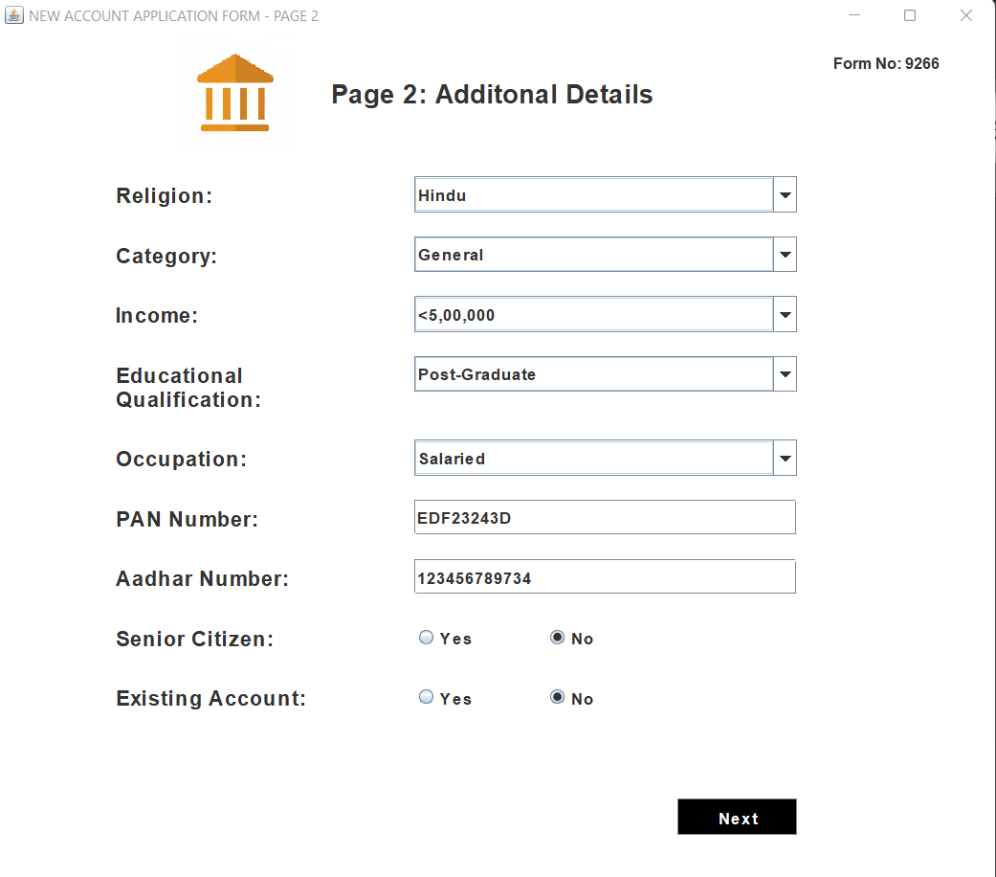

**For signup2**

package ASimulatorSystem;

import java.awt.*;

import java.awt.event.*;

import javax.swing.*;

import java.sql.*;

public class Signup2 extends JFrame implements ActionListener{

JLabel l1,l2,l3,l4,l5,l6,l7,l8,l9,l10,l11,l12,l13;

JButton b;

JRadioButton r1,r2,r3,r4;

JTextField t1,t2,t3;

JComboBox c1,c2,c3,c4,c5;

String formno;

Signup2(String formno){

ImageIcon i1 = new ImageIcon(ClassLoader.getSystemResource("ASimulatorSystem/icons/logo.jpg"));

Image i2 = i1.getImage().getScaledInstance(100, 100, Image.SCALE_DEFAULT);

ImageIcon i3 = new ImageIcon(i2);

JLabel l14 = new JLabel(i3);

l14.setBounds(150, 0, 100, 100);

add(l14);

this.formno = formno;

setTitle("NEW ACCOUNT APPLICATION FORM - PAGE 2");

l1 = new JLabel("Page 2: Additonal Details");

l1.setFont(new Font("Raleway", Font.BOLD, 22));

l2 = new JLabel("Religion:");

l2.setFont(new Font("Raleway", Font.BOLD, 18));

l3 = new JLabel("Category:");

l3.setFont(new Font("Raleway", Font.BOLD, 18));

l4 = new JLabel("Income:");

l4.setFont(new Font("Raleway", Font.BOLD, 18));

l5 = new JLabel("Educational");

l5.setFont(new Font("Raleway", Font.BOLD, 18));

l11 = new JLabel("Qualification:");

l11.setFont(new Font("Raleway", Font.BOLD, 18));

l6 = new JLabel("Occupation:");

l6.setFont(new Font("Raleway", Font.BOLD, 18));

l7 = new JLabel("PAN Number:");

l7.setFont(new Font("Raleway", Font.BOLD, 18));

l8 = new JLabel("Aadhar Number:");

l8.setFont(new Font("Raleway", Font.BOLD, 18));

l9 = new JLabel("Senior Citizen:");

l9.setFont(new Font("Raleway", Font.BOLD, 18));

l10 = new JLabel("Existing Account:");

l10.setFont(new Font("Raleway", Font.BOLD, 18));

l12 = new JLabel("Form No:");

l12.setFont(new Font("Raleway", Font.BOLD, 13));

l13 = new JLabel(formno);

l13.setFont(new Font("Raleway", Font.BOLD, 13));

b = new JButton("Next");

b.setFont(new Font("Raleway", Font.BOLD, 14));

b.setBackground(Color.BLACK);

b.setForeground(Color.WHITE);

t1 = new JTextField();

t1.setFont(new Font("Raleway", Font.BOLD, 14));

t2 = new JTextField();

t2.setFont(new Font("Raleway", Font.BOLD, 14));

r1 = new JRadioButton("Yes");

r1.setFont(new Font("Raleway", Font.BOLD, 14));

r1.setBackground(Color.WHITE);

r2 = new JRadioButton("No");

r2.setFont(new Font("Raleway", Font.BOLD, 14));

r2.setBackground(Color.WHITE);

r3 = new JRadioButton("Yes");

r3.setFont(new Font("Raleway", Font.BOLD, 14));

r3.setBackground(Color.WHITE);

r4 = new JRadioButton("No");

r4.setFont(new Font("Raleway", Font.BOLD, 14));

r4.setBackground(Color.WHITE);

String religion[] = {"Hindu","Muslim","Sikh","Christian","Other"};

c1 = new JComboBox(religion);

c1.setBackground(Color.WHITE);

c1.setFont(new Font("Raleway", Font.BOLD, 14));

String category[] = {"General","OBC","SC","ST","Other"};

c2 = new JComboBox(category);

c2.setBackground(Color.WHITE);

c2.setFont(new Font("Raleway", Font.BOLD, 14));

String income[] = {"Null","<1,50,000","<2,50,000","<5,00,000","Upto 10,00,000","Above 10,00,000"};

c3 = new JComboBox(income);

c3.setBackground(Color.WHITE);

c3.setFont(new Font("Raleway", Font.BOLD, 14));

String education[] = {"Non-Graduate","Graduate","Post-Graduate","Doctrate","Others"};

c4 = new JComboBox(education);

c4.setBackground(Color.WHITE);

c4.setFont(new Font("Raleway", Font.BOLD, 14));

String occupation[] = {"Salaried","Self-Employmed","Business","Student","Retired","Others"};

c5 = new JComboBox(occupation);

c5.setBackground(Color.WHITE);

c5.setFont(new Font("Raleway", Font.BOLD, 14));

setLayout(null);

l12.setBounds(700,10,60,30);

add(l12);

l13.setBounds(760,10,60,30);

add(l13);

l1.setBounds(280,30,600,40);

add(l1);

l2.setBounds(100,120,100,30);

add(l2);

c1.setBounds(350,120,320,30);

add(c1);

l3.setBounds(100,170,100,30);

add(l3);

c2.setBounds(350,170,320,30);

add(c2);

l4.setBounds(100,220,100,30);

add(l4);

c3.setBounds(350,220,320,30);

add(c3);

l5.setBounds(100,270,150,30);

add(l5);

c4.setBounds(350,270,320,30);

add(c4);

l11.setBounds(100,290,150,30);

add(l11);

l6.setBounds(100,340,150,30);

add(l6);

c5.setBounds(350,340,320,30);

add(c5);

l7.setBounds(100,390,150,30);

add(l7);

t1.setBounds(350,390,320,30);

add(t1);

l8.setBounds(100,440,180,30);

add(l8);

t2.setBounds(350,440,320,30);

add(t2);

l9.setBounds(100,490,150,30);

add(l9);

r1.setBounds(350,490,100,30);

add(r1);

r2.setBounds(460,490,100,30);

add(r2);

l10.setBounds(100,540,180,30);

add(l10);

r3.setBounds(350,540,100,30);

add(r3);

r4.setBounds(460,540,100,30);

add(r4);

b.setBounds(570,640,100,30);

add(b);

b.addActionListener(this);

getContentPane().setBackground(Color.WHITE);

setSize(850,750);

setLocation(500,120);

setVisible(true);

}

public void actionPerformed(ActionEvent ae){

String religion = (String)c1.getSelectedItem();

String category = (String)c2.getSelectedItem();

String income = (String)c3.getSelectedItem();

String education = (String)c4.getSelectedItem();

String occupation = (String)c5.getSelectedItem();

String pan = t1.getText();

String aadhar = t2.getText();

String scitizen = "";

if(r1.isSelected()){

scitizen = "Yes";

}

else if(r2.isSelected()){

scitizen = "No";

}

String eaccount = "";

if(r3.isSelected()){

eaccount = "Yes";

}else if(r4.isSelected()){

eaccount = "No";

}

try{

if(t2.getText().equals("")){

JOptionPane.showMessageDialog(null, "Fill all the required fields");

}else{

Conn c1 = new Conn();

String q1 = "insert into signuptwo values('"+formno+"','"+religion+"','"+category+"','"+income+"','"+education+"','"+occupation+"','"+pan+"','"+aadhar+"','"+scitizen+"','"+eaccount+"')";

c1.s.executeUpdate(q1);

new Signup3(formno).setVisible(true);

setVisible(false);

}

}catch(Exception ex){

ex.printStackTrace();

}

}

public static void main(String[] args){

new Signup2("").setVisible(true);

}

}

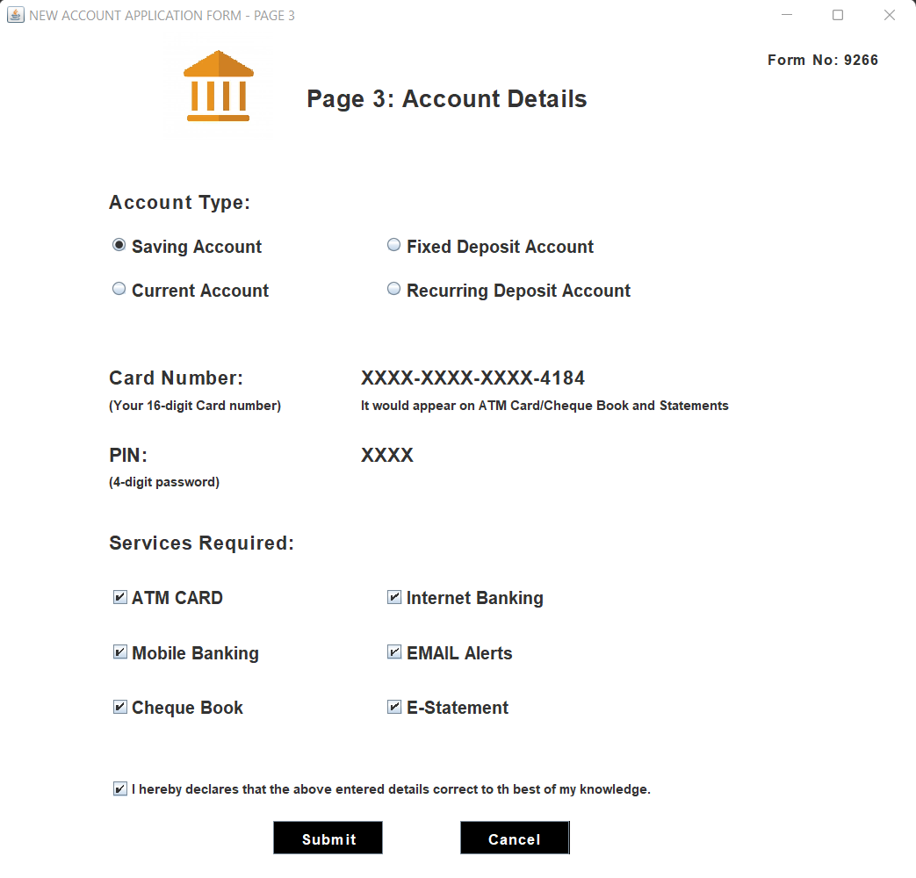

**For signup 3**

package ASimulatorSystem;

import java.awt.*;

import java.awt.event.*;

import javax.swing.*;

import java.sql.*;

import java.util.*;

public class Signup3 extends JFrame implements ActionListener{

JLabel l1,l2,l3,l4,l5,l6,l7,l8,l9,l10,l11,l12;

JRadioButton r1,r2,r3,r4;

JButton b1,b2;

JCheckBox c1,c2,c3,c4,c5,c6,c7;

String formno;

Signup3(String formno){

this.formno = formno;

setTitle("NEW ACCOUNT APPLICATION FORM - PAGE 3");

ImageIcon i1 = new ImageIcon(ClassLoader.getSystemResource("ASimulatorSystem/icons/logo.jpg"));

Image i2 = i1.getImage().getScaledInstance(100, 100, Image.SCALE_DEFAULT);

ImageIcon i3 = new ImageIcon(i2);

JLabel l14 = new JLabel(i3);

l14.setBounds(150, 0, 100, 100);

add(l14);

l1 = new JLabel("Page 3: Account Details");

l1.setFont(new Font("Raleway", Font.BOLD, 22));

l2 = new JLabel("Account Type:");

l2.setFont(new Font("Raleway", Font.BOLD, 18));

l3 = new JLabel("Card Number:");

l3.setFont(new Font("Raleway", Font.BOLD, 18));

l4 = new JLabel("XXXX-XXXX-XXXX-4184");

l4.setFont(new Font("Raleway", Font.BOLD, 18));

l5 = new JLabel("(Your 16-digit Card number)");

l5.setFont(new Font("Raleway", Font.BOLD, 12));

l6 = new JLabel("It would appear on ATM Card/Cheque Book and Statements");

l6.setFont(new Font("Raleway", Font.BOLD, 12));

l7 = new JLabel("PIN:");

l7.setFont(new Font("Raleway", Font.BOLD, 18));

l8 = new JLabel("XXXX");

l8.setFont(new Font("Raleway", Font.BOLD, 18));

l9 = new JLabel("(4-digit password)");

l9.setFont(new Font("Raleway", Font.BOLD, 12));

l10 = new JLabel("Services Required:");

l10.setFont(new Font("Raleway", Font.BOLD, 18));

l11 = new JLabel("Form No:");

l11.setFont(new Font("Raleway", Font.BOLD, 14));

l12 = new JLabel(formno);

l12.setFont(new Font("Raleway", Font.BOLD, 14));

b1 = new JButton("Submit");

b1.setFont(new Font("Raleway", Font.BOLD, 14));

b1.setBackground(Color.BLACK);

b1.setForeground(Color.WHITE);

b2 = new JButton("Cancel");

b2.setFont(new Font("Raleway", Font.BOLD, 14));

b2.setBackground(Color.BLACK);

b2.setForeground(Color.WHITE);

c1 = new JCheckBox("ATM CARD");

c1.setBackground(Color.WHITE);

c1.setFont(new Font("Raleway", Font.BOLD, 16));

c2 = new JCheckBox("Internet Banking");

c2.setBackground(Color.WHITE);

c2.setFont(new Font("Raleway", Font.BOLD, 16));

c3 = new JCheckBox("Mobile Banking");

c3.setBackground(Color.WHITE);

c3.setFont(new Font("Raleway", Font.BOLD, 16));

c4 = new JCheckBox("EMAIL Alerts");

c4.setBackground(Color.WHITE);

c4.setFont(new Font("Raleway", Font.BOLD, 16));

c5 = new JCheckBox("Cheque Book");

c5.setBackground(Color.WHITE);

c5.setFont(new Font("Raleway", Font.BOLD, 16));

c6 = new JCheckBox("E-Statement");

c6.setBackground(Color.WHITE);

c6.setFont(new Font("Raleway", Font.BOLD, 16));

c7 = new JCheckBox("I hereby declares that the above entered details correct to th best of my knowledge.",true);

c7.setBackground(Color.WHITE);

c7.setFont(new Font("Raleway", Font.BOLD, 12));

r1 = new JRadioButton("Saving Account");

r1.setFont(new Font("Raleway", Font.BOLD, 16));

r1.setBackground(Color.WHITE);

r2 = new JRadioButton("Fixed Deposit Account");

r2.setFont(new Font("Raleway", Font.BOLD, 16));

r2.setBackground(Color.WHITE);

r3 = new JRadioButton("Current Account");

r3.setFont(new Font("Raleway", Font.BOLD, 16));

r3.setBackground(Color.WHITE);

r4 = new JRadioButton("Recurring Deposit Account");

r4.setFont(new Font("Raleway", Font.BOLD, 16));

r4.setBackground(Color.WHITE);

ButtonGroup groupgender = new ButtonGroup();

groupgender.add(r1);

groupgender.add(r2);

groupgender.add(r3);

groupgender.add(r4);

setLayout(null);

l11.setBounds(700,10,70,30);

add(l11);

l12.setBounds(770,10,40,30);

add(l12);

l1.setBounds(280,40,400,40);

add(l1);

l2.setBounds(100,140,200,30);

add(l2);

r1.setBounds(100,180,150,30);

add(r1);

r2.setBounds(350,180,300,30);

add(r2);

r3.setBounds(100,220,250,30);

add(r3);

r4.setBounds(350,220,250,30);

add(r4);

l3.setBounds(100,300,200,30);

add(l3);

l4.setBounds(330,300,250,30);

add(l4);

l5.setBounds(100,330,200,20);

add(l5);

l6.setBounds(330,330,500,20);

add(l6);

l7.setBounds(100,370,200,30);

add(l7);

l8.setBounds(330,370,200,30);

add(l8);

l9.setBounds(100,400,200,20);

add(l9);

l10.setBounds(100,450,200,30);

add(l10);

c1.setBounds(100,500,200,30);

add(c1);

c2.setBounds(350,500,200,30);

add(c2);

c3.setBounds(100,550,200,30);

add(c3);

c4.setBounds(350,550,200,30);

add(c4);

c5.setBounds(100,600,200,30);

add(c5);

c6.setBounds(350,600,200,30);

add(c6);

c7.setBounds(100,680,600,20);

add(c7);

b1.setBounds(250,720,100,30);

add(b1);

b2.setBounds(420,720,100,30);

add(b2);

getContentPane().setBackground(Color.WHITE);

setSize(850,850);

setLocation(500,120);

setVisible(true);

b1.addActionListener(this);

b2.addActionListener(this);

}

public void actionPerformed(ActionEvent ae){

String atype = null;

if(r1.isSelected()){

atype = "Saving Account";

}

else if(r2.isSelected()){

atype = "Fixed Deposit Account";

}

else if(r3.isSelected()){

atype = "Current Account";

}else if(r4.isSelected()){

atype = "Recurring Deposit Account";

}

Random ran = new Random();

long first7 = (ran.nextLong() % 90000000L) + 5040936000000000L;

String cardno = "" + Math.abs(first7);

long first3 = (ran.nextLong() % 9000L) + 1000L;

String pin = "" + Math.abs(first3);

String facility = "";

if(c1.isSelected()){

facility = facility + " ATM Card";

}

if(c2.isSelected()){

facility = facility + " Internet Banking";

}

if(c3.isSelected()){

facility = facility + " Mobile Banking";

}

if(c4.isSelected()){

facility = facility + " EMAIL Alerts";

}

if(c5.isSelected()){

facility = facility + " Cheque Book";

}

if(c6.isSelected()){

facility = facility + " E-Statement";

}

try{

if(ae.getSource()==b1){

if(atype.equals("")){

JOptionPane.showMessageDialog(null, "Fill all the required fields");

}else{

Conn c1 = new Conn();

String q1 = "insert into signupthree values('"+formno+"','"+atype+"','"+cardno+"','"+pin+"','"+facility+"')";

String q2 = "insert into login values('"+formno+"','"+cardno+"','"+pin+"')";

c1.s.executeUpdate(q1);

c1.s.executeUpdate(q2);

JOptionPane.showMessageDialog(null, "Card Number: " + cardno + "\n Pin:"+ pin);

new Deposit(pin).setVisible(true);

setVisible(false);

}

}else if(ae.getSource()==b2){

System.exit(0);

}

}catch(Exception ex){

ex.printStackTrace();

}

}

public static void main(String[] args){

new Signup3("").setVisible(true);

}

}

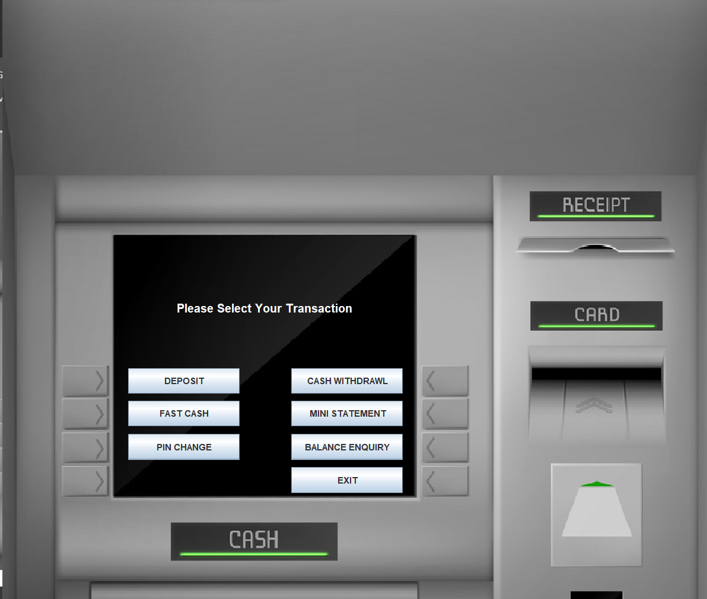

**For transaction:**

package ASimulatorSystem;

import java.awt.*;

import java.awt.event.*;

import javax.swing.*;

import java.sql.*;

public class Transactions extends JFrame implements ActionListener{

JLabel l1;

JButton b1,b2,b3,b4,b5,b6,b7;

String pin;

Transactions(String pin){

this.pin = pin;

ImageIcon i1 = new ImageIcon(ClassLoader.getSystemResource("ASimulatorSystem/icons/atm.jpg"));

Image i2 = i1.getImage().getScaledInstance(1000, 1180, Image.SCALE_DEFAULT);

ImageIcon i3 = new ImageIcon(i2);

JLabel l2 = new JLabel(i3);

l2.setBounds(0, 0, 960, 1080);

add(l2);

l1 = new JLabel("Please Select Your Transaction");

l1.setForeground(Color.WHITE);

l1.setFont(new Font("System", Font.BOLD, 16));

b1 = new JButton("DEPOSIT");

b2 = new JButton("CASH WITHDRAWL");

b3 = new JButton("FAST CASH");

b4 = new JButton("MINI STATEMENT");

b5 = new JButton("PIN CHANGE");

b6 = new JButton("BALANCE ENQUIRY");

b7 = new JButton("EXIT");

setLayout(null);

l1.setBounds(235,400,700,35);

l2.add(l1);

b1.setBounds(170,499,150,35);

l2.add(b1);

b2.setBounds(390,499,150,35);

l2.add(b2);

b3.setBounds(170,543,150,35);

l2.add(b3);

b4.setBounds(390,543,150,35);

l2.add(b4);

b5.setBounds(170,588,150,35);

l2.add(b5);

b6.setBounds(390,588,150,35);

l2.add(b6);

b7.setBounds(390,633,150,35);

l2.add(b7);

b1.addActionListener(this);

b2.addActionListener(this);

b3.addActionListener(this);

b4.addActionListener(this);

b5.addActionListener(this);

b6.addActionListener(this);

b7.addActionListener(this);

setSize(960,1080);

setLocation(500,0);

setUndecorated(true);

setVisible(true);

}

public void actionPerformed(ActionEvent ae){

if(ae.getSource()==b1){

setVisible(false);

new Deposit(pin).setVisible(true);

}else if(ae.getSource()==b2){

setVisible(false);

new Withdrawl(pin).setVisible(true);

}else if(ae.getSource()==b3){

setVisible(false);

new FastCash(pin).setVisible(true);

}else if(ae.getSource()==b4){

new MiniStatement(pin).setVisible(true);

}else if(ae.getSource()==b5){

setVisible(false);

new Pin(pin).setVisible(true);

}else if(ae.getSource()==b6){

this.setVisible(false);

new BalanceEnquiry(pin).setVisible(true);

}else if(ae.getSource()==b7){

System.exit(0);

}

}

public static void main(String[] args){

new Transactions("").setVisible(true);

}

}

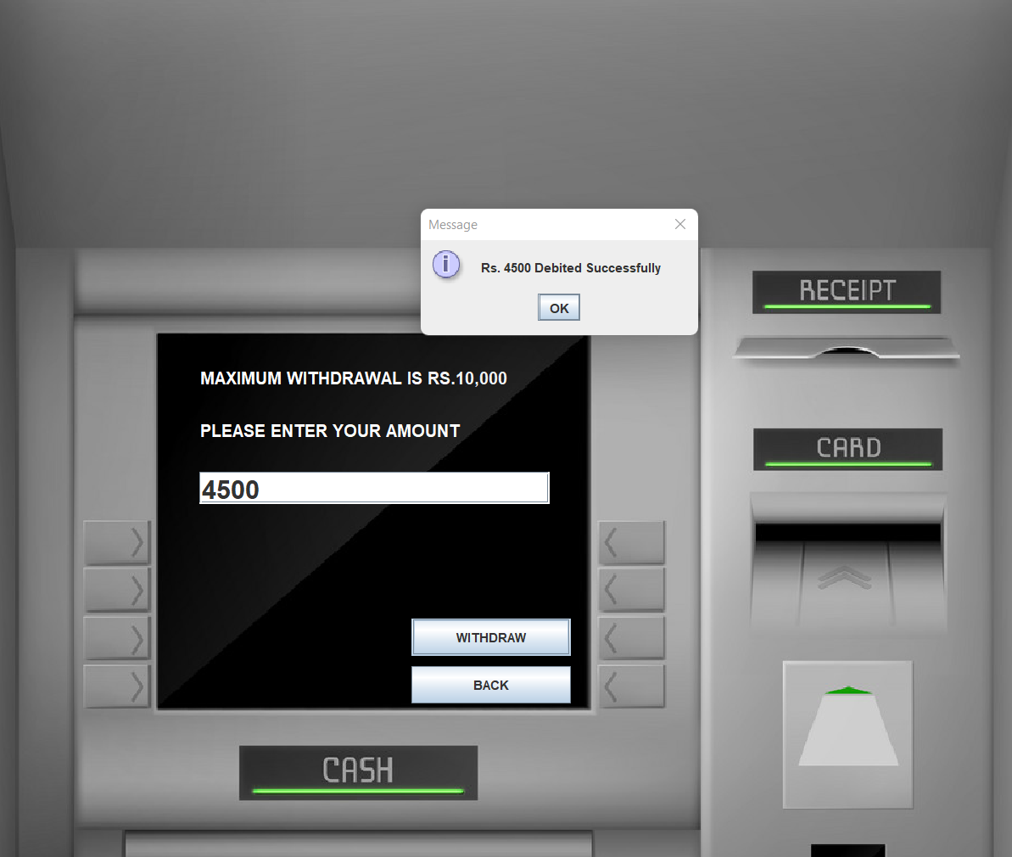

**For withdrawal** :

package ASimulatorSystem;

import java.awt.*;

import java.awt.event.*;

import javax.swing.*;

import java.util.Date;

import java.sql.*;

public class Withdrawl extends JFrame implements ActionListener{

JTextField t1,t2;

JButton b1,b2,b3;

JLabel l1,l2,l3,l4;

String pin;

Withdrawl(String pin){

this.pin = pin;

ImageIcon i1 = new ImageIcon(ClassLoader.getSystemResource("ASimulatorSystem/icons/atm.jpg"));

Image i2 = i1.getImage().getScaledInstance(1000, 1180, Image.SCALE_DEFAULT);

ImageIcon i3 = new ImageIcon(i2);

JLabel l3 = new JLabel(i3);

l3.setBounds(0, 0, 960, 1080);

add(l3);

l1 = new JLabel("MAXIMUM WITHDRAWAL IS RS.10,000");

l1.setForeground(Color.WHITE);

l1.setFont(new Font("System", Font.BOLD, 16));

l2 = new JLabel("PLEASE ENTER YOUR AMOUNT");

l2.setForeground(Color.WHITE);

l2.setFont(new Font("System", Font.BOLD, 16));

t1 = new JTextField();

t1.setFont(new Font("Raleway", Font.BOLD, 25));

b1 = new JButton("WITHDRAW");

b2 = new JButton("BACK");

setLayout(null);

l1.setBounds(190,350,400,20);

l3.add(l1);

l2.setBounds(190,400,400,20);

l3.add(l2);

t1.setBounds(190,450,330,30);

l3.add(t1);

b1.setBounds(390,588,150,35);

l3.add(b1);

b2.setBounds(390,633,150,35);

l3.add(b2);

b1.addActionListener(this);

b2.addActionListener(this);

setSize(960,1080);

setLocation(500,0);

setUndecorated(true);

setVisible(true);

}

public void actionPerformed(ActionEvent ae){

try{

String amount = t1.getText();

Date date = new Date();

if(ae.getSource()==b1){

if(t1.getText().equals("")){

JOptionPane.showMessageDialog(null, "Please enter the Amount to you want to Withdraw");

}else{

Conn c1 = new Conn();

ResultSet rs = c1.s.executeQuery("select * from bank where pin = '"+pin+"'");

int balance = 0;

while(rs.next()){

if(rs.getString("type").equals("Deposit")){

balance += Integer.parseInt(rs.getString("amount"));

}else{

balance -= Integer.parseInt(rs.getString("amount"));

}

}

if(balance < Integer.parseInt(amount)){

JOptionPane.showMessageDialog(null, "Insuffient Balance");

return;

}

c1.s.executeUpdate("insert into bank values('"+pin+"', '"+date+"', 'Withdrawl', '"+amount+"')");

JOptionPane.showMessageDialog(null, "Rs. "+amount+" Debited Successfully");

setVisible(false);

new Transactions(pin).setVisible(true);

}

}else if(ae.getSource()==b2){

setVisible(false);

new Transactions(pin).setVisible(true);

}

}catch(Exception e){

e.printStackTrace();

System.out.println("error: "+e);

}

}

public static void main(String[] args){

new Withdrawl("").setVisible(true);

}

}

**FOR PRACTICE**

package ASimulatorSystem;

import javax.imageio.ImageIO;

import javax.swing.*;

import javax.swing.filechooser.FileNameExtensionFilter;

import java.awt.*;

import java.awt.image.BufferedImage;

import java.io.File;

public final class Practice {

boolean negative;

public Practice() {

this(false);

}

public Practice(final boolean negative) {

this.negative = negative;

}

public String convert(final BufferedImage image) {

StringBuilder sb = new StringBuilder((image.getWidth() + 1) * image.getHeight());

for (int y = 0; y < image.getHeight(); y++) {

if (sb.length() != 0) sb.append("\n");

for (int x = 0; x < image.getWidth(); x++) {

Color pixelColor = new Color(image.getRGB(x, y));

double gValue = (double) pixelColor.getRed() * 0.2989 + (double) pixelColor.getBlue() * 0.5870 + (double) pixelColor.getGreen() * 0.1140;

final char s = negative ? returnStrNeg(gValue) : returnStrPos(gValue);

sb.append(s);

}

}

return sb.toString();

}

/**

* Create a new string and assign to it a string based on the grayscale value.

* If the grayscale value is very high, the pixel is very bright and assign characters

* such as . and , that do not appear very dark. If the grayscale value is very lowm the pixel is very dark,

* assign characters such as # and @ which appear very dark.

*

* @param g grayscale

* @return char

*/

private char returnStrPos(double g)//takes the grayscale value as parameter

{

final char str;

if (g >= 230.0) {

str = ' ';

} else if (g >= 200.0) {

str = '.';

} else if (g >= 180.0) {

str = '*';

} else if (g >= 160.0) {

str = ':';

} else if (g >= 130.0) {

str = 'o';

} else if (g >= 100.0) {

str = '&';

} else if (g >= 70.0) {

str = '8';

} else if (g >= 50.0) {

str = '#';

} else {

str = '@';

}

return str; // return the character

}

/**

* Same method as above, except it reverses the darkness of the pixel. A dark pixel is given a light character and vice versa.

*

* @param g grayscale

* @return char

*/

private char returnStrNeg(double g) {

final char str;

if (g >= 230.0) {

str = '@';

} else if (g >= 200.0) {

str = '#';

} else if (g >= 180.0) {

str = '8';

} else if (g >= 160.0) {

str = '&';

} else if (g >= 130.0) {

str = 'o';

} else if (g >= 100.0) {

str = ':';

} else if (g >= 70.0) {

str = '*';

} else if (g >= 50.0) {

str = '.';

} else {

str = ' ';

}

return str;

}

public static void main(String[] args) {

SwingUtilities.invokeLater(new Runnable() {

@Override

public void run() {

JFileChooser fileChooser = new JFileChooser();

fileChooser.setFileFilter(new FileNameExtensionFilter("Images", "jpg", "gif", "png"));

while (fileChooser.showOpenDialog(null) == JFileChooser.APPROVE_OPTION) {

try {

File f = fileChooser.getSelectedFile();

final BufferedImage image = ImageIO.read(f);

if (image == null) throw new IllegalArgumentException(f + " is not a valid image.");

final String ascii = new Practice().convert(image);

final JTextArea textArea = new JTextArea(ascii, image.getHeight(), image.getWidth());

textArea.setFont(new Font("Monospaced", Font.BOLD, 5));

textArea.setEditable(false);

final JDialog dialog = new JOptionPane(new JScrollPane(textArea), JOptionPane.PLAIN_MESSAGE).createDialog(Practice.class.getName());

dialog.setResizable(true);

dialog.setVisible(true);

} catch (Exception e) {

JOptionPane.showMessageDialog(null, e.toString(), "Error", JOptionPane.ERROR_MESSAGE);

}

}

System.exit(0);

}

});

}

}

**FOR PIN**

package ASimulatorSystem;

import java.awt.*;

import java.awt.event.*;

import javax.swing.*;

import java.sql.*;

public class Pin extends JFrame implements ActionListener{

JPasswordField t1,t2;

JButton b1,b2;

JLabel l1,l2,l3;

String pin;

Pin(String pin){

this.pin = pin;

ImageIcon i1 = new ImageIcon(ClassLoader.getSystemResource("ASimulatorSystem/icons/atm.jpg"));

Image i2 = i1.getImage().getScaledInstance(1000, 1180, Image.SCALE_DEFAULT);

ImageIcon i3 = new ImageIcon(i2);

JLabel l4 = new JLabel(i3);

l4.setBounds(0, 0, 960, 1080);

add(l4);

l1 = new JLabel("CHANGE YOUR PIN");

l1.setFont(new Font("System", Font.BOLD, 16));

l1.setForeground(Color.WHITE);

l2 = new JLabel("New PIN:");

l2.setFont(new Font("System", Font.BOLD, 16));

l2.setForeground(Color.WHITE);

l3 = new JLabel("Re-Enter New PIN:");

l3.setFont(new Font("System", Font.BOLD, 16));

l3.setForeground(Color.WHITE);

t1 = new JPasswordField();

t1.setFont(new Font("Raleway", Font.BOLD, 25));

t2 = new JPasswordField();

t2.setFont(new Font("Raleway", Font.BOLD, 25));

b1 = new JButton("CHANGE");

b2 = new JButton("BACK");

b1.addActionListener(this);

b2.addActionListener(this);

setLayout(null);

l1.setBounds(280,330,800,35);

l4.add(l1);

l2.setBounds(180,390,150,35);

l4.add(l2);

l3.setBounds(180,440,200,35);

l4.add(l3);

t1.setBounds(350,390,180,25);

l4.add(t1);

t2.setBounds(350,440,180,25);

l4.add(t2);

b1.setBounds(390,588,150,35);

l4.add(b1);

b2.setBounds(390,633,150,35);

l4.add(b2);

setSize(960,1080);

setLocation(500,0);

setUndecorated(true);

setVisible(true);

}

public void actionPerformed(ActionEvent ae){

try{

String npin = t1.getText();

String rpin = t2.getText();

if(!npin.equals(rpin)){

JOptionPane.showMessageDialog(null, "Entered PIN does not match");

return;

}

if(ae.getSource()==b1){

if (t1.getText().equals("")){

JOptionPane.showMessageDialog(null, "Enter New PIN");

}

if (t2.getText().equals("")){

JOptionPane.showMessageDialog(null, "Re-Enter new PIN");

}

Conn c1 = new Conn();

String q1 = "update bank set pin = '"+rpin+"' where pin = '"+pin+"' ";

String q2 = "update login set pin = '"+rpin+"' where pin = '"+pin+"' ";

String q3 = "update signupthree set pin = '"+rpin+"' where pin = '"+pin+"' ";

c1.s.executeUpdate(q1);

c1.s.executeUpdate(q2);

c1.s.executeUpdate(q3);

JOptionPane.showMessageDialog(null, "PIN changed successfully");

setVisible(false);

new Transactions(rpin).setVisible(true);

}else if(ae.getSource()==b2){

new Transactions(pin).setVisible(true);

setVisible(false);

}

}catch(Exception e){

e.printStackTrace();

}

}

public static void main(String[] args){

new Pin("").setVisible(true);

}

}

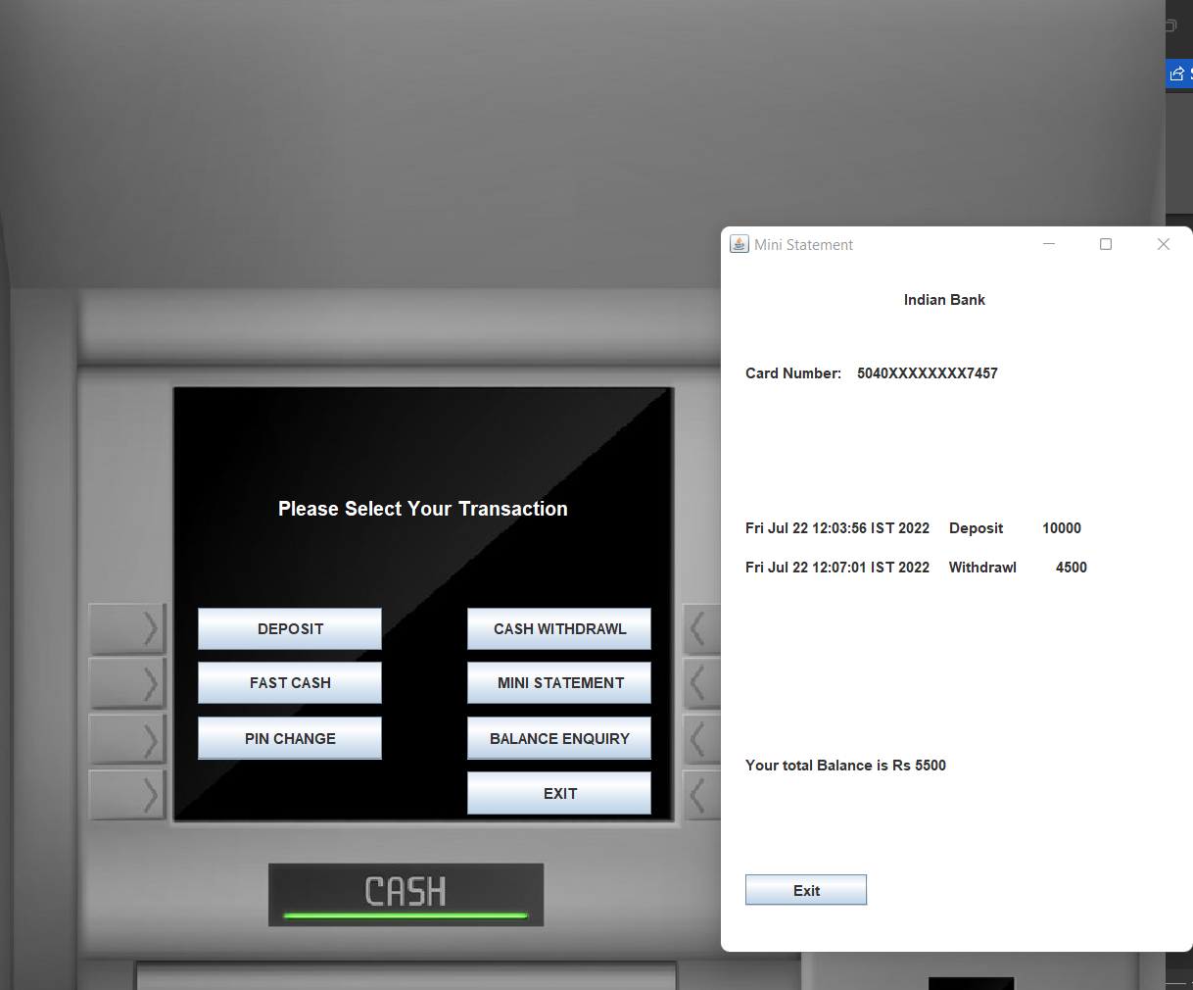

**FOR MINISTATEMEN**

package ASimulatorSystem;

import java.awt.*;

import java.awt.event.*;

import javax.swing.*;

import java.sql.*;

public class MiniStatement extends JFrame implements ActionListener{

JButton b1, b2;

JLabel l1;

MiniStatement(String pin){

super("Mini Statement");

getContentPane().setBackground(Color.WHITE);

setSize(400,600);

setLocation(20,20);

l1 = new JLabel();

add(l1);

JLabel l2 = new JLabel("Indian Bank");

l2.setBounds(150, 20, 100, 20);

add(l2);

JLabel l3 = new JLabel();

l3.setBounds(20, 80, 300, 20);

add(l3);

JLabel l4 = new JLabel();

l4.setBounds(20, 400, 300, 20);

add(l4);

try{

Conn c = new Conn();

ResultSet rs = c.s.executeQuery("select * from login where pin = '"+pin+"'");

while(rs.next()){

l3.setText("Card Number: " + rs.getString("cardnumber").substring(0, 4) + "XXXXXXXX" + rs.getString("cardnumber").substring(12));

}

}catch(Exception e){}

try{

int balance = 0;

Conn c1 = new Conn();

ResultSet rs = c1.s.executeQuery("SELECT * FROM bank where pin = '"+pin+"'");

while(rs.next()){

l1.setText(l1.getText() + "<html>"+rs.getString("date")+ "&nbsp;&nbsp;&nbsp;&nbsp;&nbsp;" + rs.getString("type") + "&nbsp;&nbsp;&nbsp;&nbsp;&nbsp;&nbsp;&nbsp;&nbsp;&nbsp;&nbsp;" + rs.getString("amount") + "<br><br><html>");

if(rs.getString("type").equals("Deposit")){

balance += Integer.parseInt(rs.getString("amount"));

}else{

balance -= Integer.parseInt(rs.getString("amount"));

}

}

l4.setText("Your total Balance is Rs "+balance);

}catch(Exception e){

e.printStackTrace();

}

setLayout(null);

b1 = new JButton("Exit");

add(b1);

b1.addActionListener(this);

l1.setBounds(20, 140, 400, 200);

b1.setBounds(20, 500, 100, 25);

}

public void actionPerformed(ActionEvent ae){

this.setVisible(false);

}

public static void main(String[] args){

new MiniStatement("").setVisible(true);

}

}

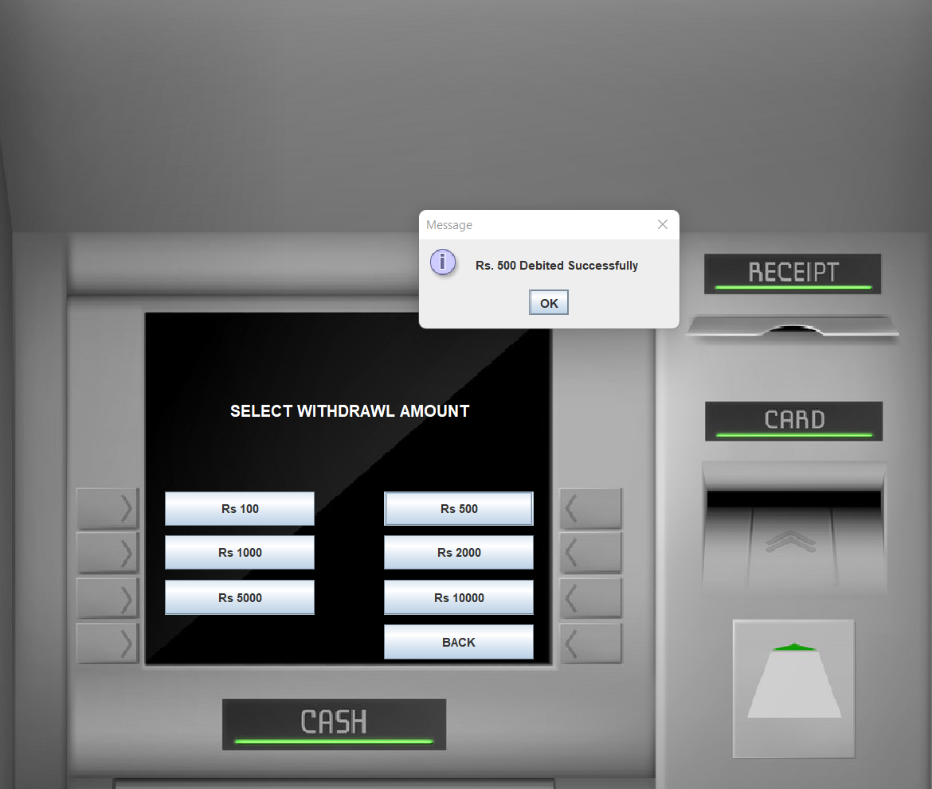

**FOR FAST CASE**

package ASimulatorSystem;

import java.awt.*;

import java.awt.event.*;

import javax.swing.*;

import java.sql.*;

import java.util.Date;

public class FastCash extends JFrame implements ActionListener {

JLabel l1, l2;

JButton b1, b2, b3, b4, b5, b6, b7, b8;

JTextField t1;

String pin;

FastCash(String pin) {

this.pin = pin;

ImageIcon i1 = new ImageIcon(ClassLoader.getSystemResource("ASimulatorSystem/icons/atm.jpg"));

Image i2 = i1.getImage().getScaledInstance(1000, 1180, Image.SCALE_DEFAULT);

ImageIcon i3 = new ImageIcon(i2);

JLabel l3 = new JLabel(i3);

l3.setBounds(0, 0, 960, 1080);

add(l3);

l1 = new JLabel("SELECT WITHDRAWL AMOUNT");

l1.setForeground(Color.WHITE);

l1.setFont(new Font("System", Font.BOLD, 16));

b1 = new JButton("Rs 100");

b2 = new JButton("Rs 500");

b3 = new JButton("Rs 1000");

b4 = new JButton("Rs 2000");

b5 = new JButton("Rs 5000");

b6 = new JButton("Rs 10000");

b7 = new JButton("BACK");

setLayout(null);

l1.setBounds(235, 400, 700, 35);

l3.add(l1);

b1.setBounds(170, 499, 150, 35);

l3.add(b1);

b2.setBounds(390, 499, 150, 35);

l3.add(b2);

b3.setBounds(170, 543, 150, 35);

l3.add(b3);

b4.setBounds(390, 543, 150, 35);

l3.add(b4);

b5.setBounds(170, 588, 150, 35);

l3.add(b5);

b6.setBounds(390, 588, 150, 35);

l3.add(b6);

b7.setBounds(390, 633, 150, 35);

l3.add(b7);

b1.addActionListener(this);

b2.addActionListener(this);

b3.addActionListener(this);

b4.addActionListener(this);

b5.addActionListener(this);

b6.addActionListener(this);

b7.addActionListener(this);

setSize(960, 1080);

setLocation(500, 0);

setUndecorated(true);

setVisible(true);

}

public void actionPerformed(ActionEvent ae) {

try {

String amount = ((JButton)ae.getSource()).getText().substring(3); //k

Conn c = new Conn();

ResultSet rs = c.s.executeQuery("select * from bank where pin = '"+pin+"'");

int balance = 0;

while (rs.next()) {

if (rs.getString("type").equals("Deposit")) {

balance += Integer.parseInt(rs.getString("amount"));

} else {

balance -= Integer.parseInt(rs.getString("amount"));

}

} String num = "17";

if (ae.getSource() != b7 && balance < Integer.parseInt(amount)) {

JOptionPane.showMessageDialog(null, "Insuffient Balance");

return;

}

if (ae.getSource() == b7) {

this.setVisible(false);

new Transactions(pin).setVisible(true);

}else{

Date date = new Date();

c.s.executeUpdate("insert into bank values('"+pin+"', '"+date+"', 'Withdrawl', '"+amount+"')");

JOptionPane.showMessageDialog(null, "Rs. "+amount+" Debited Successfully");

setVisible(false);

new Transactions(pin).setVisible(true);

}

} catch (Exception e) {

e.printStackTrace();

}

}

public static void main(String[] args) {

new FastCash("").setVisible(true);

}

}

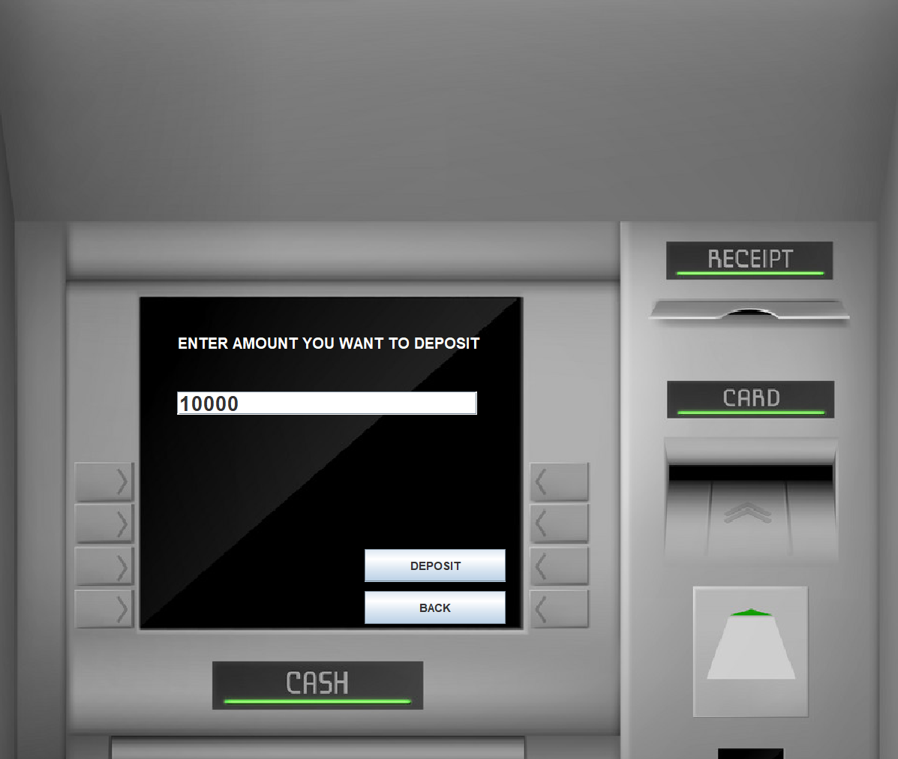

**FOR DEPOSIT**

package ASimulatorSystem;

import java.awt.*;

import java.awt.event.*;

import javax.swing.*;

import java.util.*;

public class Deposit extends JFrame implements ActionListener{

JTextField t1,t2;

JButton b1,b2,b3;

JLabel l1,l2,l3;

String pin;

Deposit(String pin){

this.pin = pin;

ImageIcon i1 = new ImageIcon(ClassLoader.getSystemResource("ASimulatorSystem/icons/atm.jpg"));

Image i2 = i1.getImage().getScaledInstance(1000, 1180, Image.SCALE_DEFAULT);

ImageIcon i3 = new ImageIcon(i2);

JLabel l3 = new JLabel(i3);

l3.setBounds(0, 0, 960, 1080);

add(l3);

l1 = new JLabel("ENTER AMOUNT YOU WANT TO DEPOSIT");

l1.setForeground(Color.WHITE);

l1.setFont(new Font("System", Font.BOLD, 16));

t1 = new JTextField();

t1.setFont(new Font("Raleway", Font.BOLD, 22));

b1 = new JButton("DEPOSIT");

b2 = new JButton("BACK");

setLayout(null);

l1.setBounds(190,350,400,35);

l3.add(l1);

t1.setBounds(190,420,320,25);

l3.add(t1);

b1.setBounds(390,588,150,35);

l3.add(b1);

b2.setBounds(390,633,150,35);

l3.add(b2);

b1.addActionListener(this);

b2.addActionListener(this);

setSize(960,1080);

setUndecorated(true);

setLocation(500,0);

setVisible(true);

}

public void actionPerformed(ActionEvent ae){

try{

String amount = t1.getText();

Date date = new Date();

if(ae.getSource()==b1){

if(t1.getText().equals("")){

JOptionPane.showMessageDialog(null, "Please enter the Amount to you want to Deposit");

}else{

Conn c1 = new Conn();

c1.s.executeUpdate("insert into bank values('"+pin+"', '"+date+"', 'Deposit', '"+amount+"')");

JOptionPane.showMessageDialog(null, "Rs. "+amount+" Deposited Successfully");

setVisible(false);

new Transactions(pin).setVisible(true);

}

}else if(ae.getSource()==b2){

setVisible(false);

new Transactions(pin).setVisible(true);

}

}catch(Exception e){

e.printStackTrace();

}

}

public static void main(String[] args){

new Deposit("").setVisible(true);

}

}

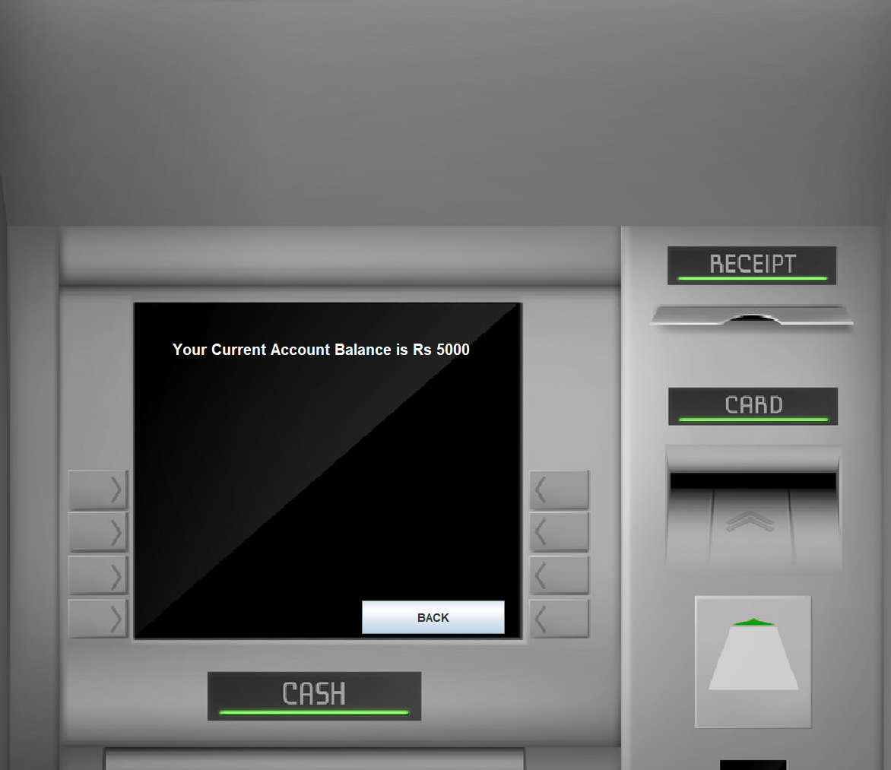

**FOR BALANCE ENQUERY**

package ASimulatorSystem;

import java.awt.*;

import java.awt.event.*;

import java.sql.ResultSet;

import javax.swing.*;

import java.util.*;

class BalanceEnquiry extends JFrame implements ActionListener {

JTextField t1, t2;

JButton b1, b2, b3;

JLabel l1, l2, l3;

String pin;

BalanceEnquiry(String pin) {

this.pin = pin;

ImageIcon i1 = new ImageIcon(ClassLoader.getSystemResource("ASimulatorSystem/icons/atm.jpg"));

Image i2 = i1.getImage().getScaledInstance(1000, 1180, Image.SCALE_DEFAULT);

ImageIcon i3 = new ImageIcon(i2);

JLabel l3 = new JLabel(i3);

l3.setBounds(0, 0, 960, 1080);

add(l3);

l1 = new JLabel();

l1.setForeground(Color.WHITE);

l1.setFont(new Font("System", Font.BOLD, 16));

b1 = new JButton("BACK");

setLayout(null);

l1.setBounds(190, 350, 400, 35);

l3.add(l1);

b1.setBounds(390, 633, 150, 35);

l3.add(b1);

int balance = 0;

try{

Conn c1 = new Conn();

ResultSet rs = c1.s.executeQuery("select * from bank where pin = '"+pin+"'");

while (rs.next()) {

if (rs.getString("type").equals("Deposit")) {

balance += Integer.parseInt(rs.getString("amount"));

} else {

balance -= Integer.parseInt(rs.getString("amount"));

}

}

}catch(Exception e){}

l1.setText("Your Current Account Balance is Rs "+balance);

b1.addActionListener(this);

setSize(960, 1080);

setUndecorated(true);

setLocation(500, 0);

setVisible(true);

}

public void actionPerformed(ActionEvent ae) {

setVisible(false);

new Transactions(pin).setVisible(true);

}

public static void main(String[] args) {

new BalanceEnquiry("").setVisible(true);

}

}

**FOR CON:**

package ASimulatorSystem;

import java.sql.*;

public class Conn{

Connection c;

Statement s;

public Conn(){

try{

Class.forName("com.mysql.cj.jdbc.Driver");

c =DriverManager.getConnection("jdbc:mysql://localhost:3306/databasemanagementsystem","root","nill@1234");

s =c.createStatement();

}catch(Exception e){

System.out.println(e);

}

}

}

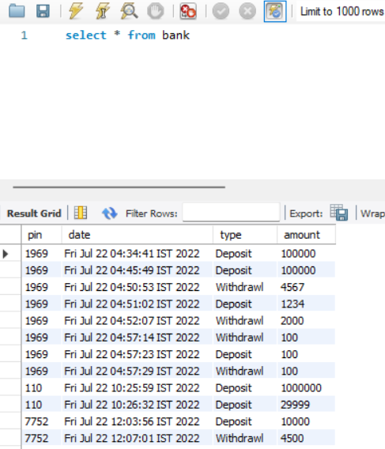

**Conclusion**

This project is developed to nurture the needs of a user in a banking sector by embedding all the tasks of transactions taking place in a bank. Future version of this project will still be much enhanced than the current version. Writing and depositing checks are perhaps the most fundamental ways to move money in and out of a checking account, but advancements in technology have added ATM and debit card transactions. All banks have rules about how long it takes to access your deposits, how many debit card transactions you're allowed in a day, and how much cash you can withdraw from an ATM. Access to the balance in your checking account can also be limited by businesses tht place holds on your funds. A Banks are providing internet banking services also so that the customers can be attracted. By asking the bank employs we came to know that maximum numbers of internet bank account holders are youth and business man. Online banking is an innovative tool that is fast becoming a necessity. It is a successful strategic weapon for banks to remain profitable in a volatile and competitive marketplace of today. If proper training should be given to customer by the bank employs to open an account will be beneficial secondly the website should be made friendlier from where the customers can directly make and access their accounts. Thus, the Bank Management System it is developed and executed successfully.

**Future Look**

The “Banking Online System is a big and ambitious project. I am thankful for being provided this great opportunity to work on it. As already mentioned, this project has gone through extensive research work. On the basis of the research work, we have successfully designed and implemented banking online System. To know what the future of online banking looks like, it’s probably worth looking at the present – online banking isn’t new. When you think of online banking, you probably think about a computer (either a desktop or laptop), a three or four step security process and then an interface that lets you view the balance of your various bank accounts and credit cards, whilst permitting you to transfer money and pay bills. And you’re not wrong either. The most valuable future looks are following below:

1- More branches of the bank, maybe it will be international, that means more ATM machines outside.

2- Customer issues development based on their needs, so the help desk will be aware of their needs and easy to use.

3- Developing a mobile App for banking system that help users to do the obtained his operations without go to the bank only he needs to sign in using his A/C NO. And password and then use your own PIN. Finally the system will update automatically.

**Reference**

1. Code for Interview YouTube Channel (https://www.youtube.com/playlist?list=PL5BFcXE899zxVrWaO3Ul6ly2SVJMnJFOr)

2. Online Bank Account Management System

Website: http://www.slideshare.net (Collect some info for report documents)

3. Learning MYSQL, JavaScript, jQuery, PHP, HTML, CSS3,

Website: http://www.w3schools.com

4. PHP and MySQL video tutorials

Website: http://www.freehinditutorial.com, http://www.youtube.com

5. Veneeva, V. (2006), “E-Banking (Online Banking) and Its Role in Today's Society”,

Ezine articles

6. JavaScript validation for empty input field

Website:http://stackoverflow.com/questions/3937513/javascript-validation-for-empty-

input-field ,

7. JavaScript form validation: Validate Password, Validate Email, Validate Phone

Number, http://webcheatsheet.com/javascript/form_validation.php